WEEK 14 STRUCTURES AND UNIONS
ROLL NO.: 241801269
NAME: Siddharth Radhakrishnan
Q1)
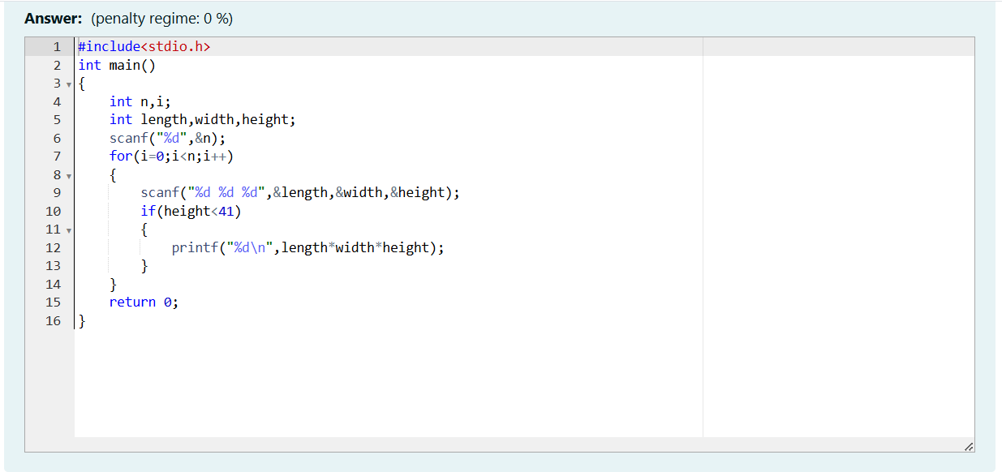

Q2)
